**Section 4**

**TRUNC**

**select hiredate,**

**trunc(hiredate,'month')**

**from singer;**

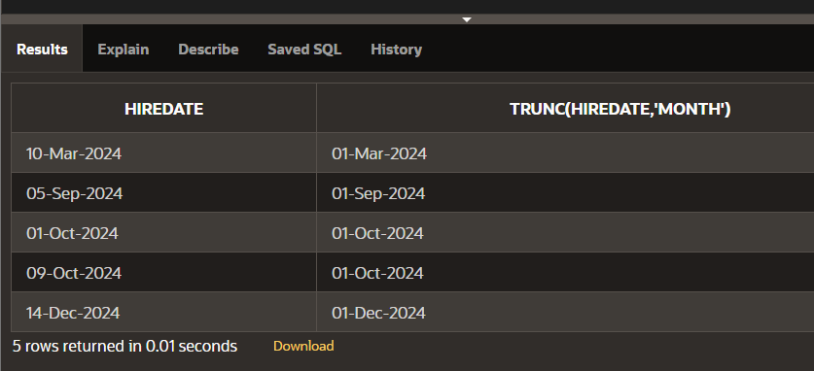

**ROUND TO HIREDATE**

**select hiredate,**

**round(hiredate,'month')**

**from singer;**

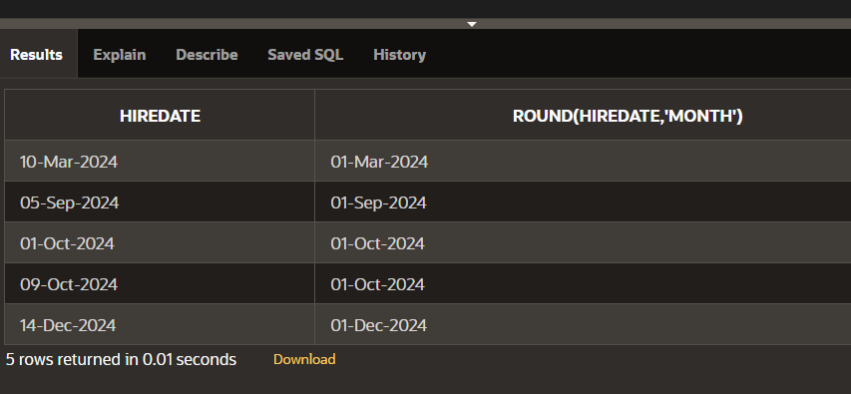

**LAST DAY**

**select last_day(sysdate)**

**from dual;**

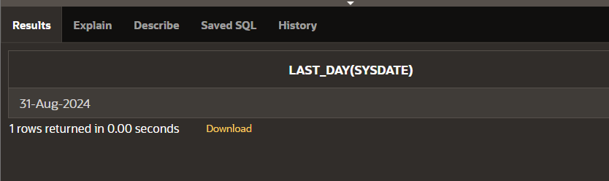

**NEXT DAY**

**select next_day(sysdate,'monday')**

**from dual;**

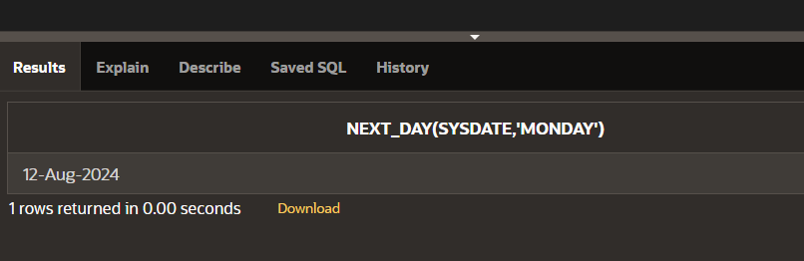

**ADD MONTHS**

**select add_months(sysdate,5)**

**from dual;**

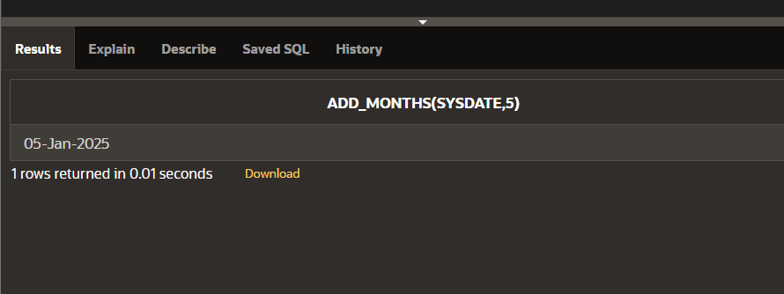

**MONTHS BETWEEN**

**select id,name**

**from singer**

**where months_between**

**(sysdate,hiredate)<100;**

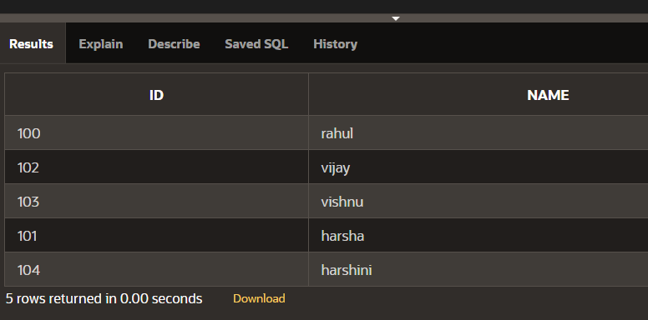

**Section 5**

**NVL FUNCTION**

**select id,nvl(dept,'not assigned')**

**from singer;**

**NVL DATE**

**SELECT NVL(TO_CHAR(hiredate, 'YYYY-MM-DD'), 'no date')**

**FROM singer;**

**CHARACTER TO DATE**

**select to_date('may10,1989','fxmondd,yyyy') as "convert"**

**from dual;**

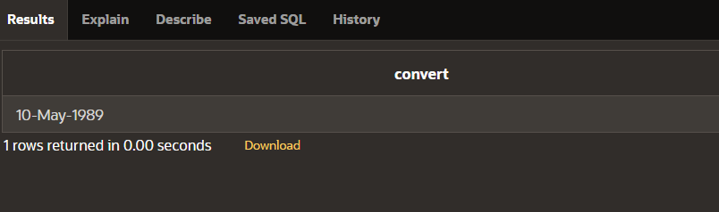

**NUMBER TO CHARACTER**

**select to_char(salary,'$99,999')**

**from singer;**

**DATE TO CHARACTER**

**select to_char(hiredate,'month dd,yyyy')**

**from singer;**

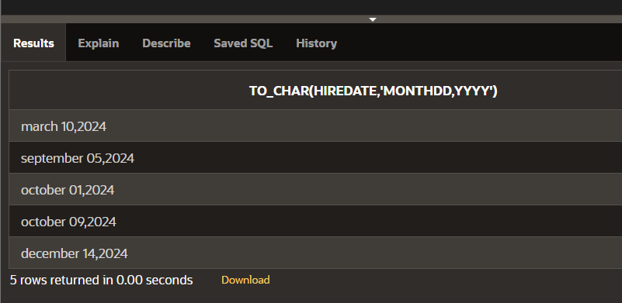

**DATE FUNCTION**

**select id,name,hiredate,round(months_between(sysdate,hiredate)) as tenure, add_months(hiredate,6) as review, next_day(hiredate,'friday'),last_day(hiredate)**

**from singer;**

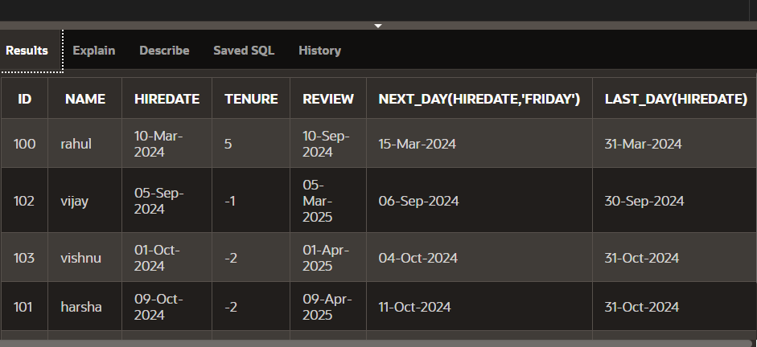

**Section 6**

**HEARIACHEY LEVEL**

**select level id,name,deptid**

**from emp**

**start with id=100**

**connect by prior id=deptid;**

**HIERACHIAL USING START WITH KEYWORD**

**select id,name,deptid**

**from emp**

**start with id=100**

**connect by prior id=deptid;**

**FULL OUTER JOIN**

**select e.id,e.name,d.deptid,d.dept_name**

**from emp e full outer join dept d**

**on (e.deptid=d.deptid);**

**RIGHT OUTER JOIN**

**select e.id,e.name,d.deptid,d.dept_name**

**from emp e right outer join dept d**

**on (e.deptid=d.deptid);**

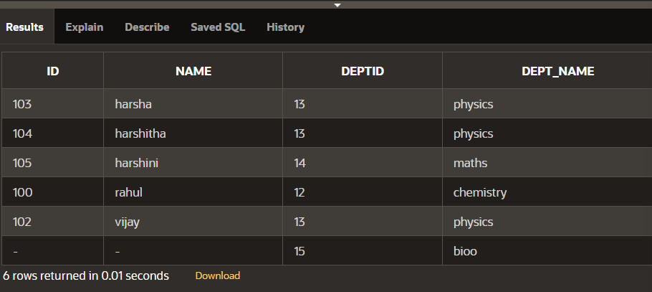

**LEFT OUTER JOIN**

**select e.id,e.name,d.deptid,d.dept_name**

**from emp e left outer join dept d**

**on (e.deptid=d.deptid);**

**ON CLAUSE**

**select id,name,dept_name**

**from emp e join dept d**

**on(e.deptid=d.deptid);**

**USING CLAUSE**

**select id,name,deptid,dept_name**

**from emp join dept using (deptid);**

**CROSS JOIN**

**select id,name,dept_name**

**from emp cross join dept;**

**NATURAL JOIN**

**select id,name,deptid,dept_name**

**from emp natural join dept;**

**7.1 Oracle Equijoin and Cartesian Product**

**CREATE TABLE employ(**

**eno VARCHAR(14),**

**ename VARCHAR(14),**

**eadhress VARCHAR(15),**

**epno VARCHAR(15),**

**depno VARCHAR(14),**

**depname VARCHAR(14),**

**jobid VARCHAR(10),**

**salary VARCHAR(10),**

**create_date DATE DEFAULT SYSDATE);**

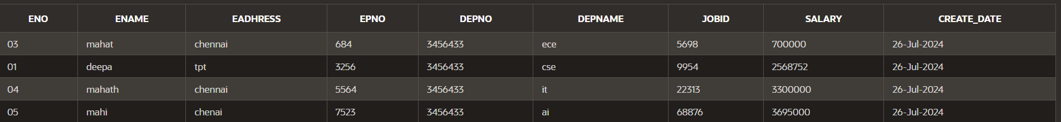

**CREATE TABLE jobs (**

**job_id VARCHAR(10) PRIMARY KEY,**

**job_title VARCHAR(50) NOT NULL,**

**min_salary DECIMAL(8, 2),**

**max_salary DECIMAL(8, 2)**

**);**



**PROPRIETARY JOINS:**

**SELECT employ.ename, jobs.job_title**

**FROM employ,jobs**

**WHERE employ.jobid=jobs.job_id;**

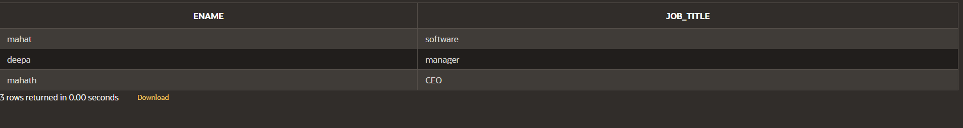

**EQUIJOIN:**

**SELECT employ.ename, employ.jobid, jobs.job_title**

**FROM employ, jobs**

**WHERE employ.jobid = jobs.job_id;**

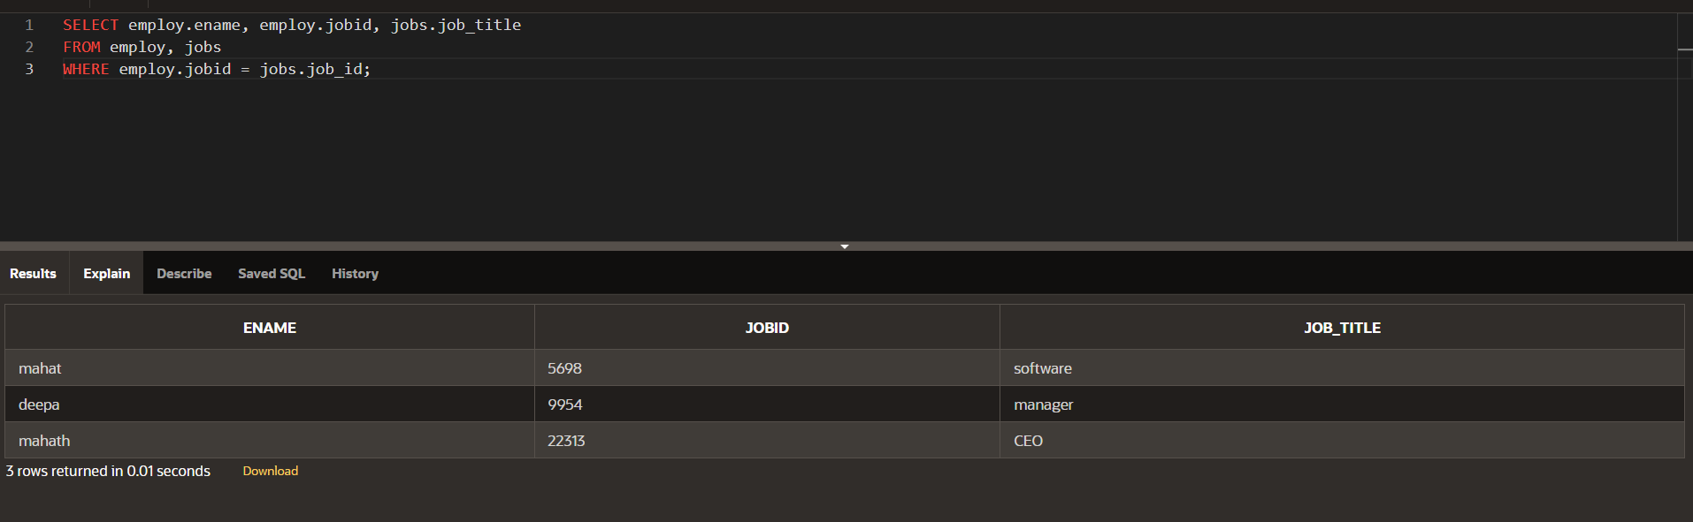

**ALIASES:**

**SELECT ename, e.jobid, job_title**

**FROM employ e, jobs j**

**WHERE e.jobid = j.job_id**

**AND depno=3456433;**

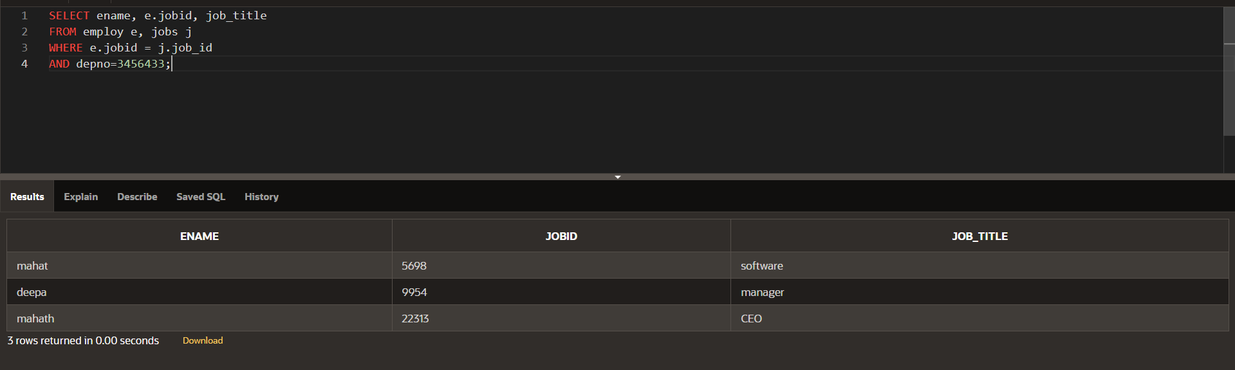

**CARTESIAN PRODUCT JOIN:**

**SELECT employ.ename,jobs.job_title**

**FROM employ,jobs;**

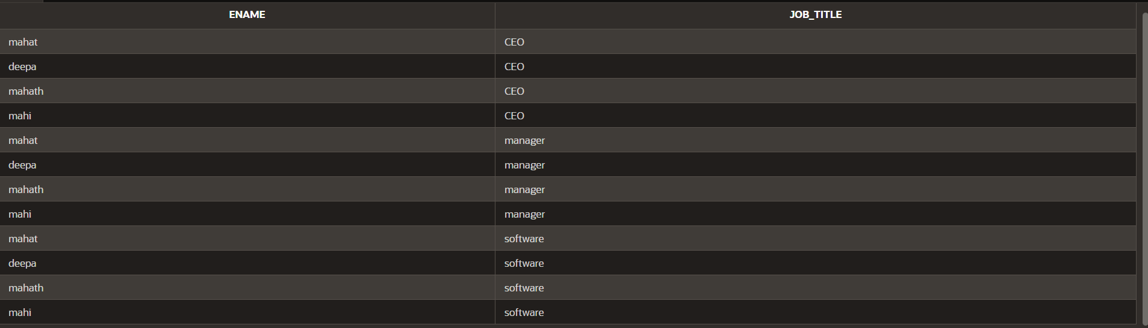

**JOIN:**

**SELECT last_name, location**

**FROM Employes e, departments d, jobs j**

**WHERE e.job_id = j.job_id**

**AND e.department_id =d.department_id;**

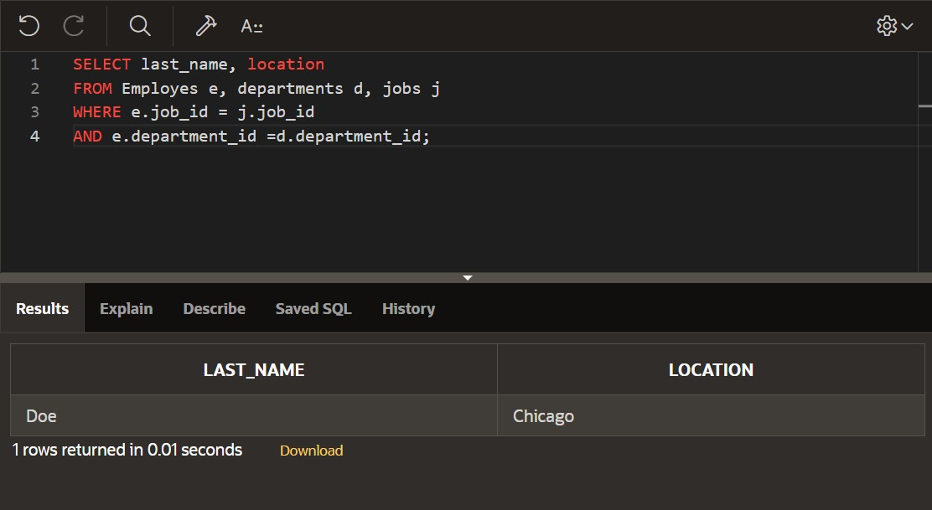

**DP_7.2:**

**Nonequijoin:**

**SELECT ename,salary,grade,lowsal,**

**highsal**

**FROM employ,job_grade**

**WHERE (salary BETWEEN lowsal AND highsal);**

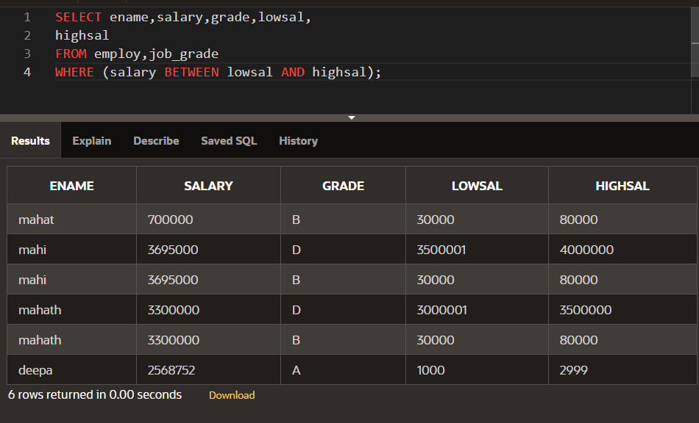

**SECTION 8**

**DP_8.1:**

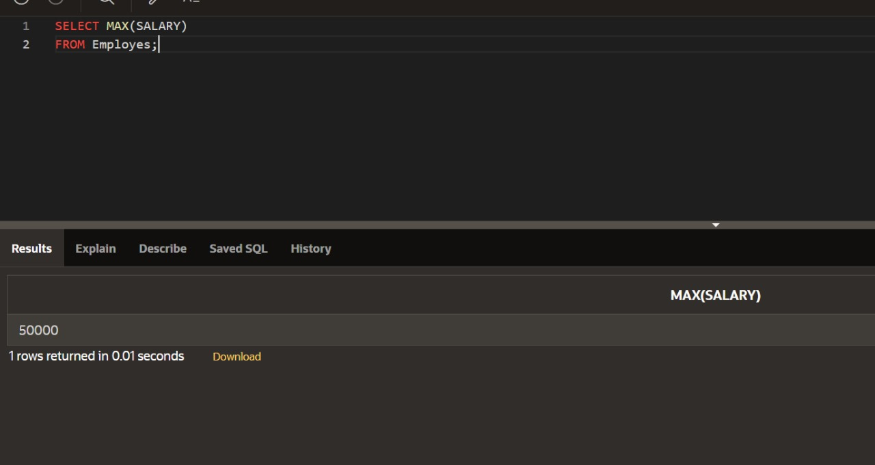

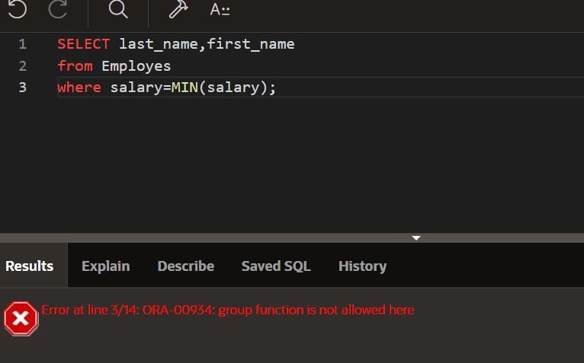

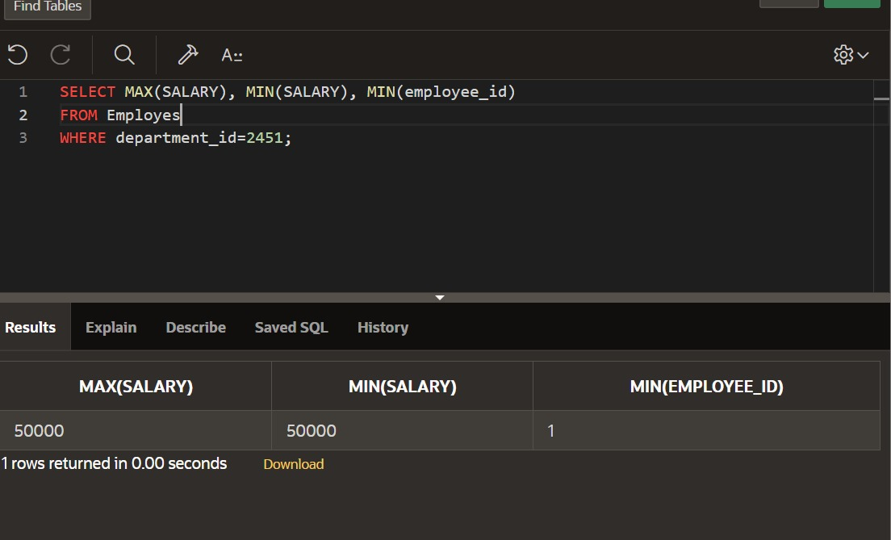

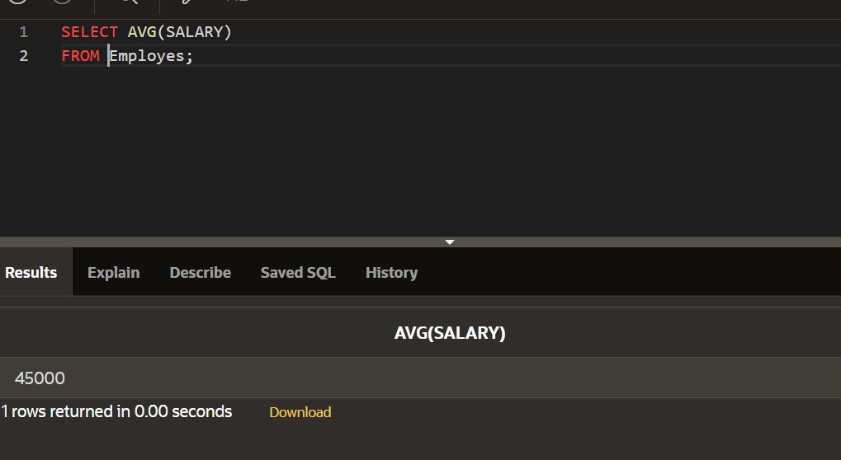

**DP_8.2:**

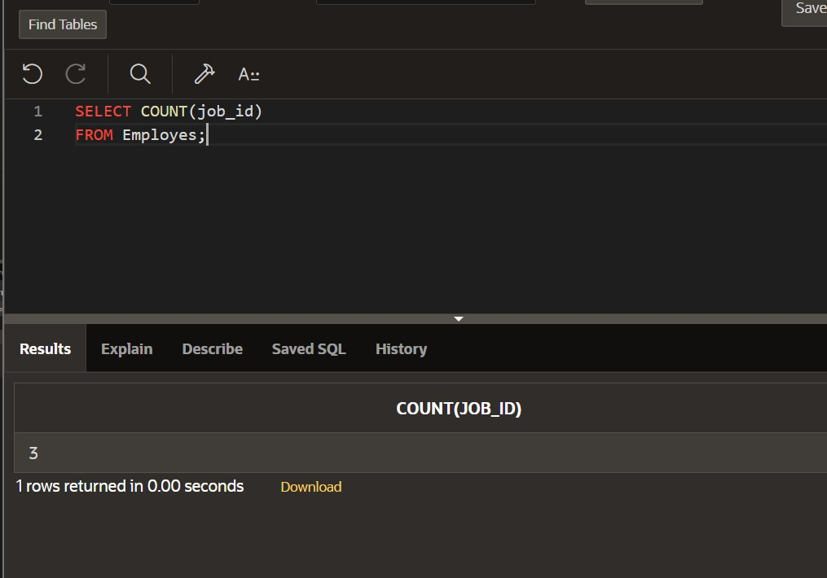 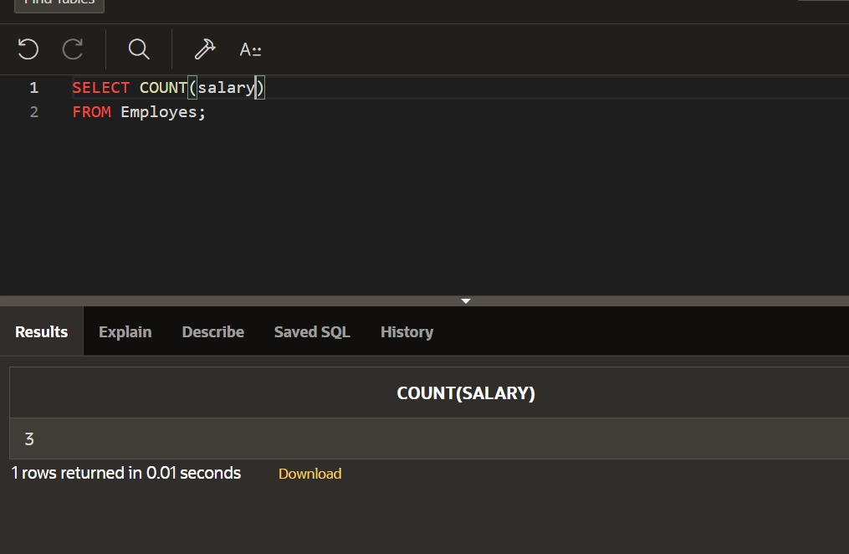 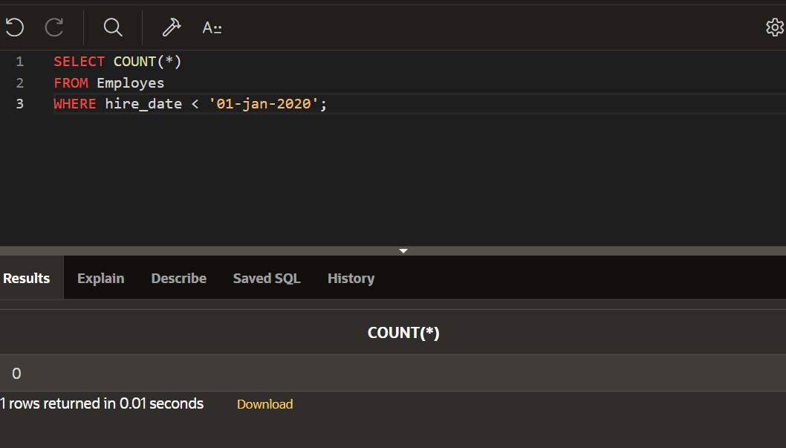 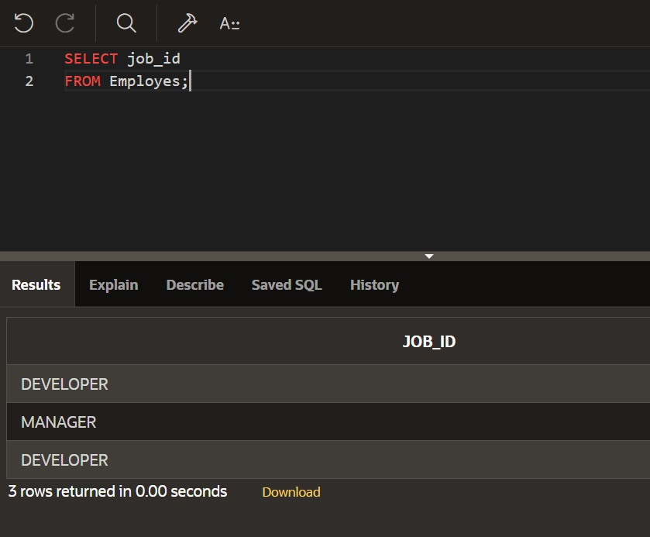 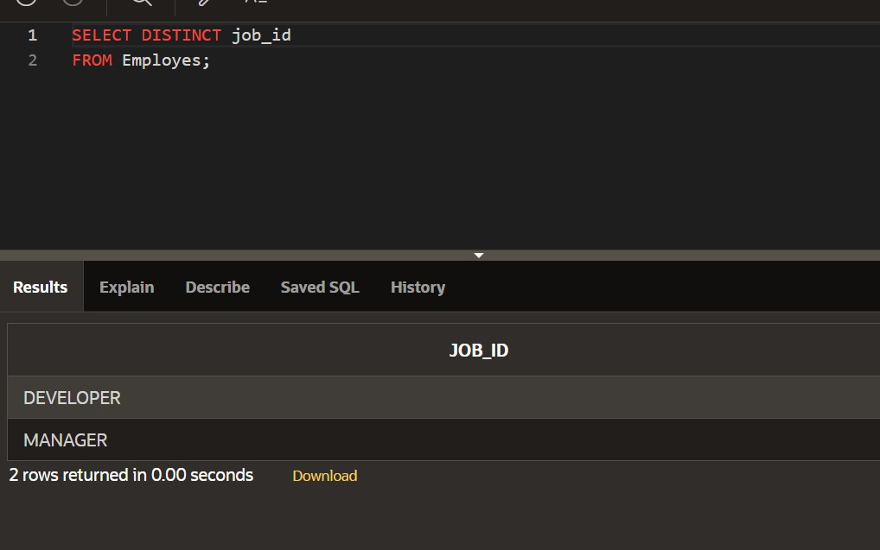 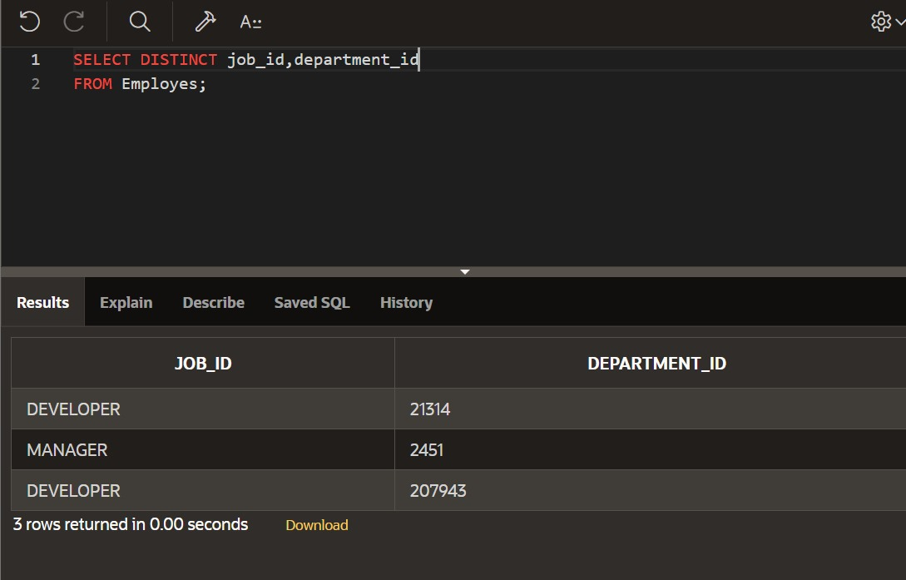 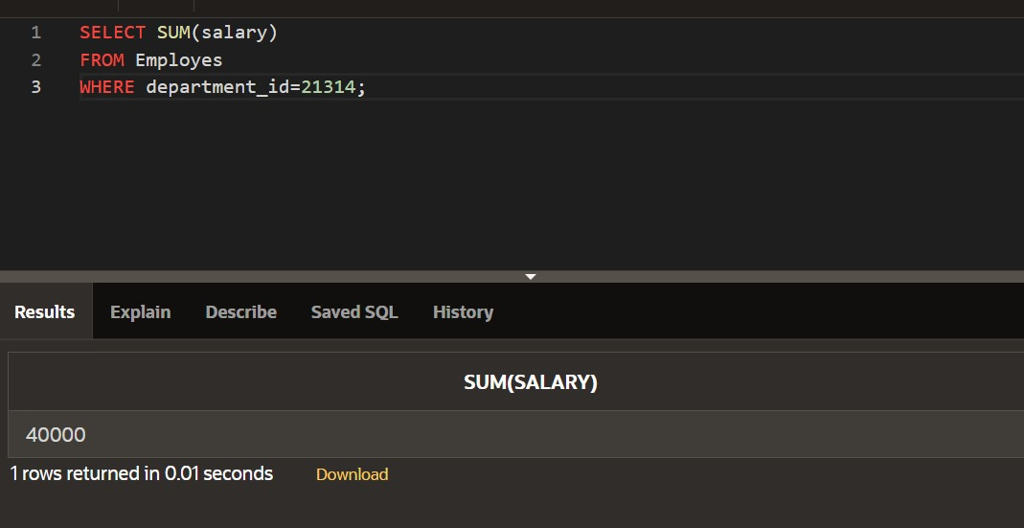 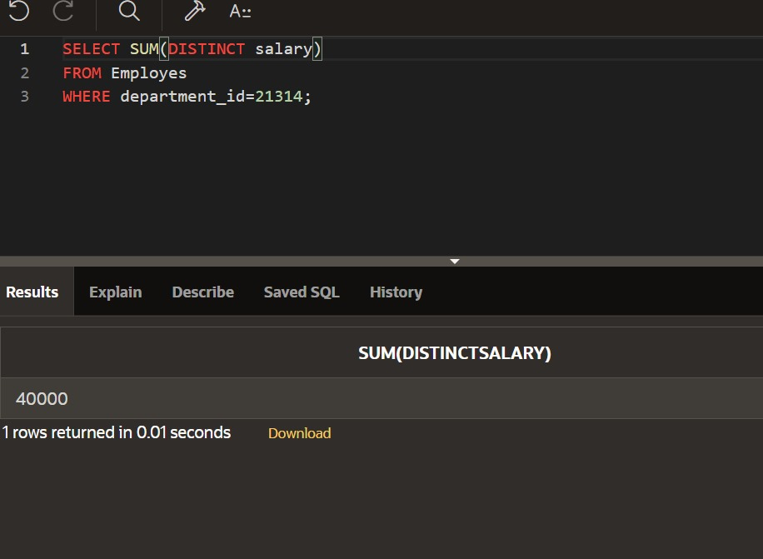 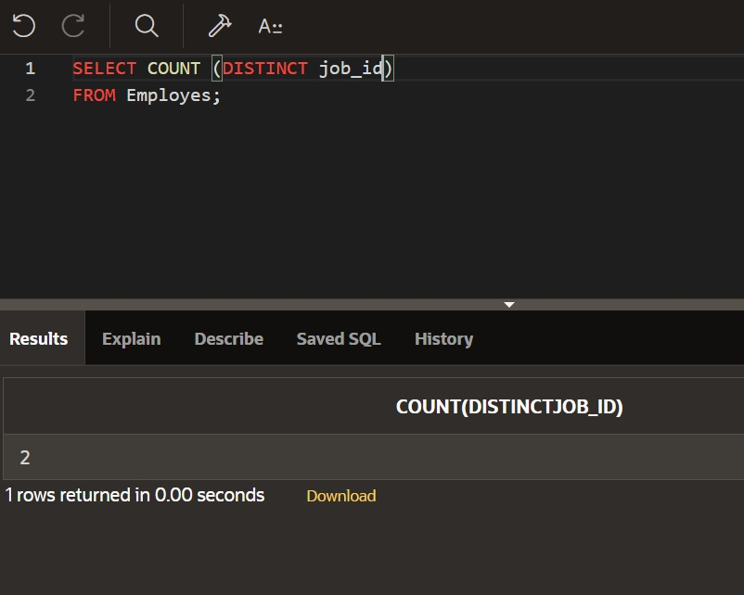 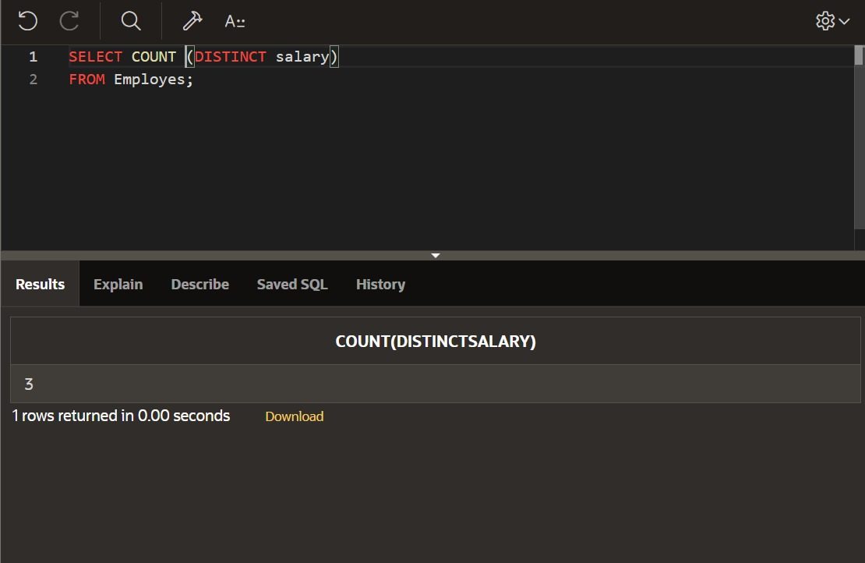 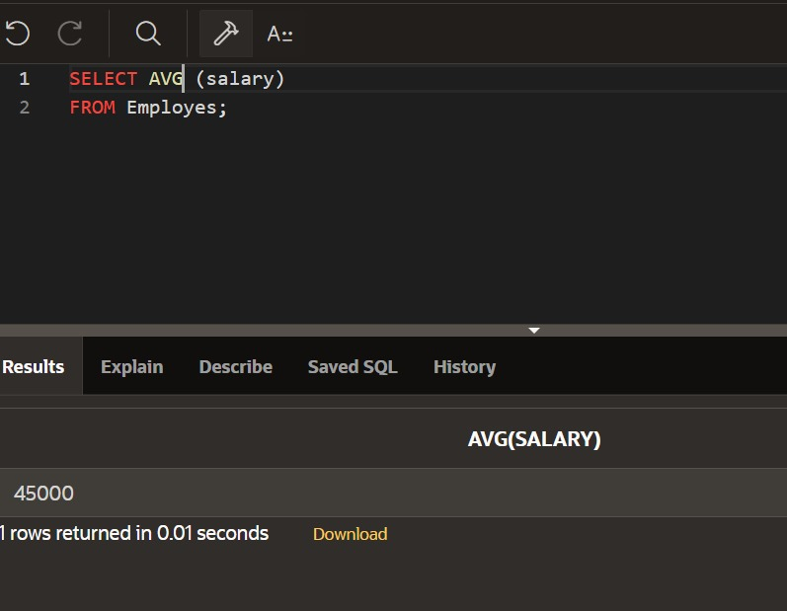

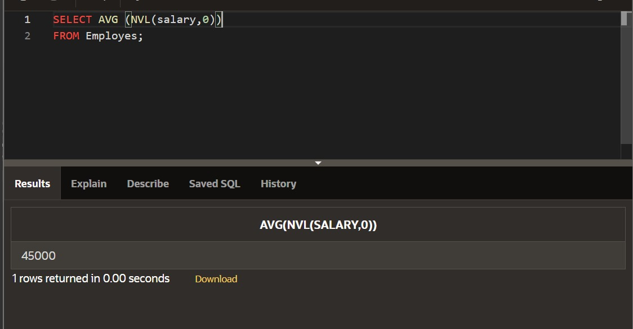



**Section 9**

**DP 9.1:**

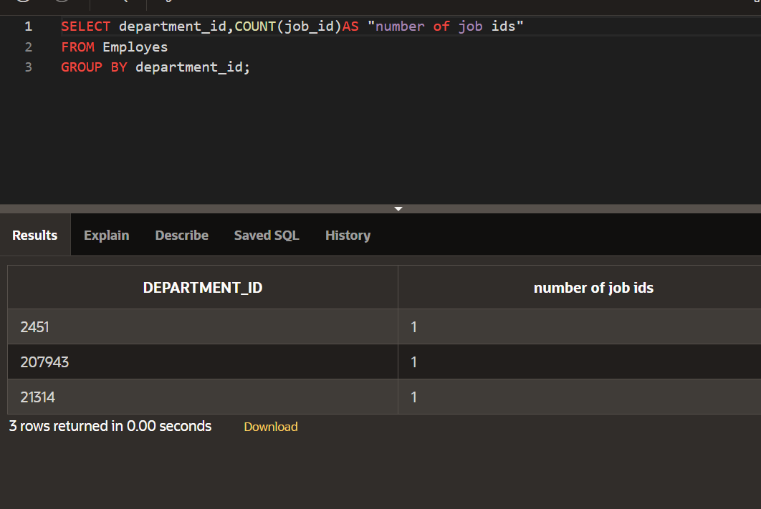

**DP 9.2:**

**DP 9.3:**

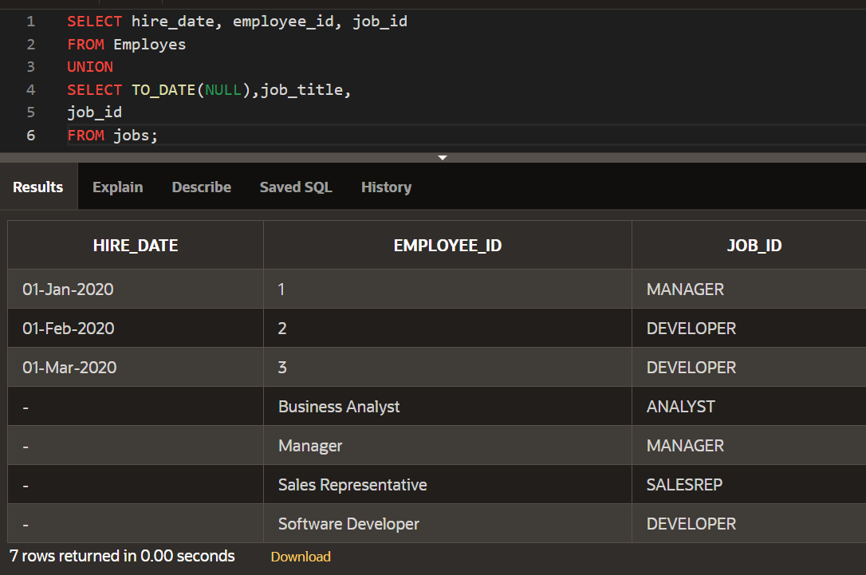

**Section-11**

**DP 11.1:**

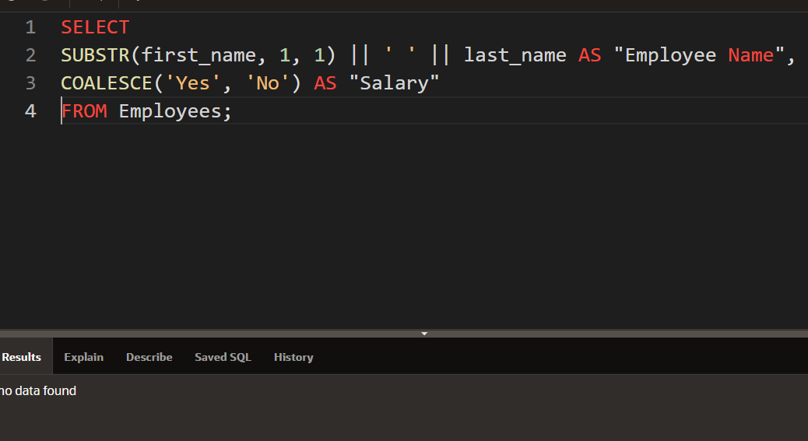

**Section-14**

**DP 14.1:**

